Deep Learning Performance metrics on HAR with Wearable Sensor (Mobile) on M-Health dataset

Metric | LSTM | BiLSTM | GRS-BiLSTM | MS-GRS-BiLSTM
Precision | 0.8320 | 0.9006 | 0.9349 | 0.9886
Recall | 0.7988 | 0.8711 | 0.9369 | 0.9906
F1-Score | 0.7894 | 0.8648 | 0.9335 | 0.9894
Test Accuracy | 0.7912 | 0.8656 | 0.9335 | 0.9901
Test Loss | 0.5843 | 0.3782 | 0.1868 | 0.0573
Cohen’s Kappa | 0.7715 | 0.8528 | 0.9272 | 0.9891
Matthews Corr. Coef (MCC) | 0.7759 | 0.8567 | 0.9277 | 0.9891
Model Parameters | 1,488 | 5,276 | 3,483 | 422,351
Model Size | 0.03 MB | 0.08 MB | 0.07 MB | 4.92 MB
Avg Batch Inference Time | 0.41 ms | 0.48 ms | 1.32 ms | 5.07 ms
Single Sample Inference Time | 0.0064 ms | 0.0037 ms | 0.0103 ms | 0.0396 ms
Throughput | 155,673 samples/sec | 267,305 samples/sec | 96,657 samples/sec | 25,243 samples/sec

Confusion Matrix
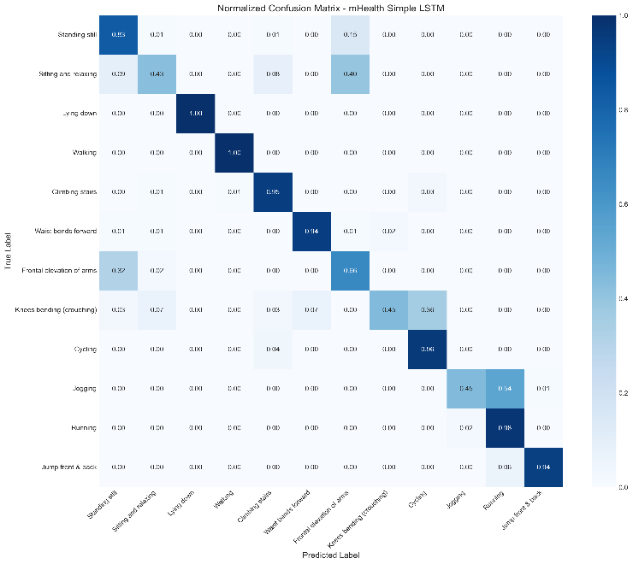 | 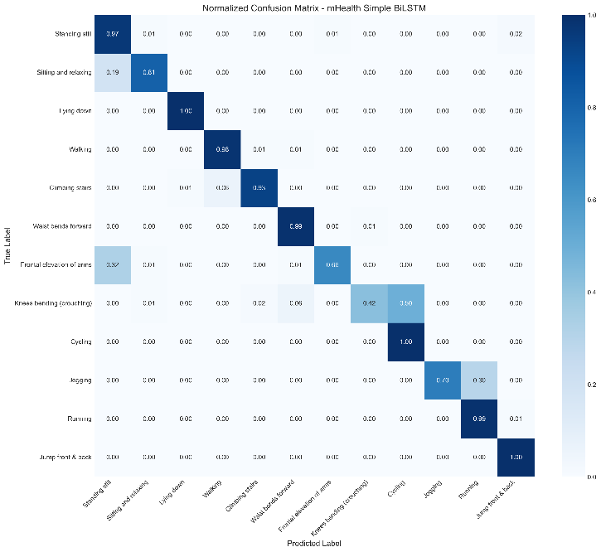
LSTM | BiLSTM
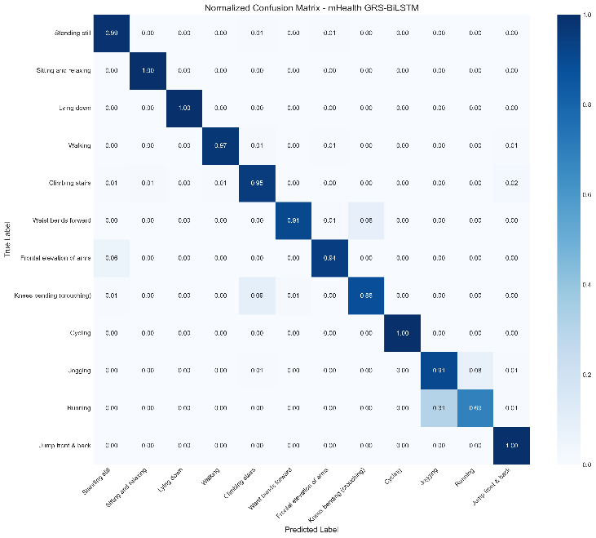 | 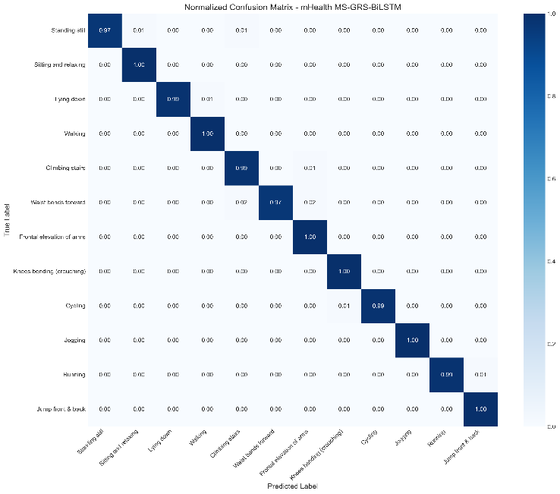
GRS-BiLSTM | MS-GRS-BiLSTM

Accuracy Loss Curve
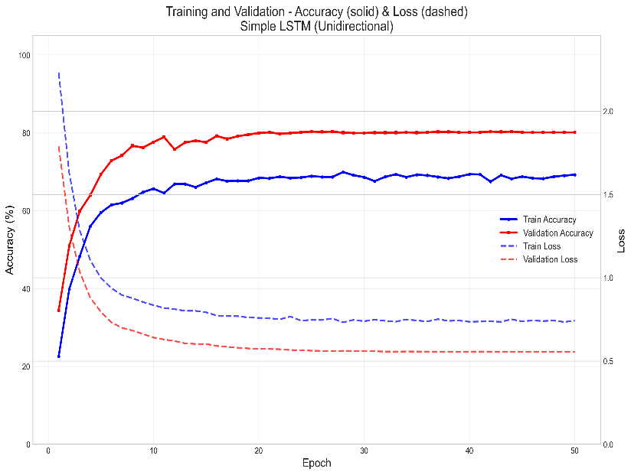 | 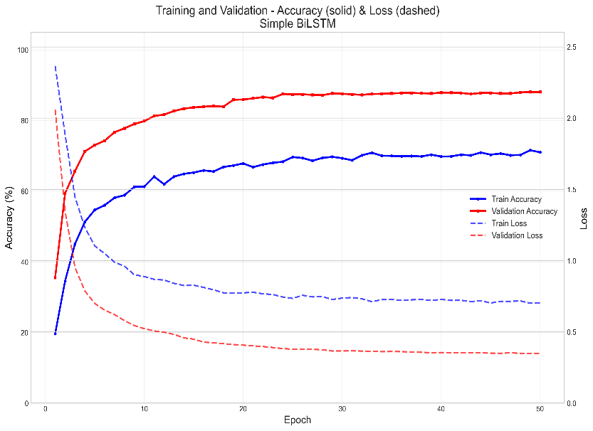
LSTM | BiLSTM
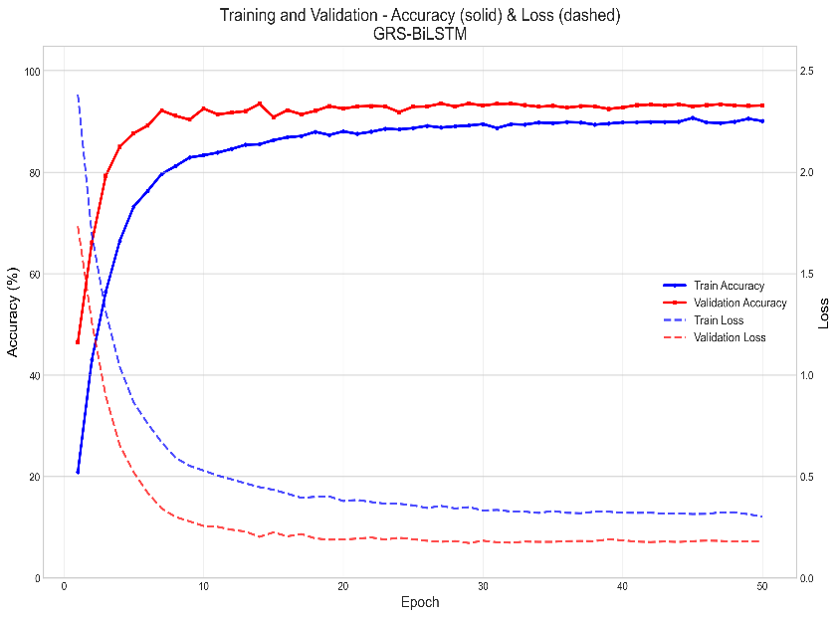 | 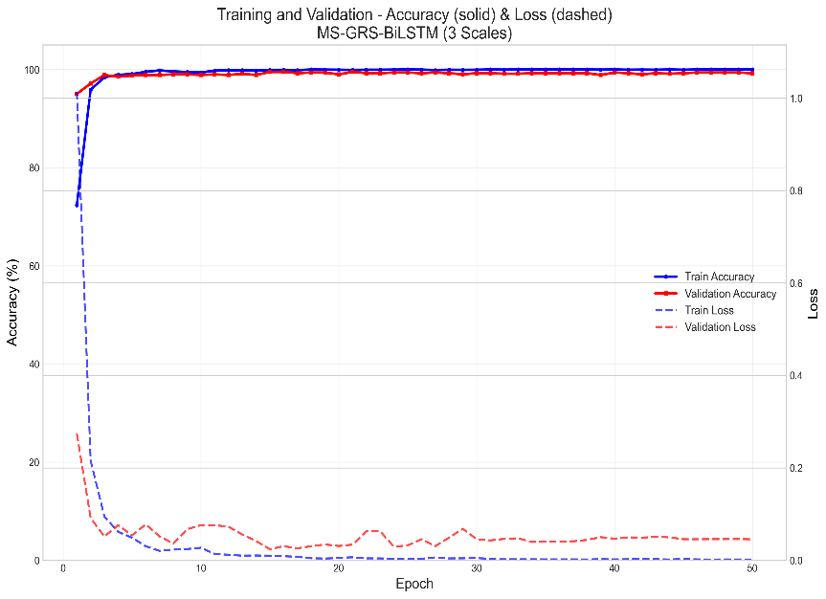
GRS-BiLSTM | MS-GRS-BiLSTM

